**Active directory Setup Week 1:**

Contents:

1. Setting up Windows Server and Windows 10 in VirtualBox
2. Setting up Active Directory Domain Services in Windows Server
3. Setting up DNS in Active Directory
4. Connecting Windows Client to Windows Server

**Setting up Windows Server and Windows 10 in VirtualBox**

Step 1: Copy Windows Server and Windows 10 .iso/.ova files from USB to your Desktop.

Step 2: Open VirtualBox and click on the “**File**” button in the top right corner of the VirtualBox Graphical User Interface.

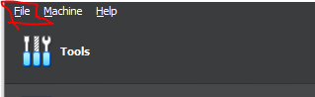

After that, you will find another button called “**Import Appliance**” You will see this window pop up 🡪 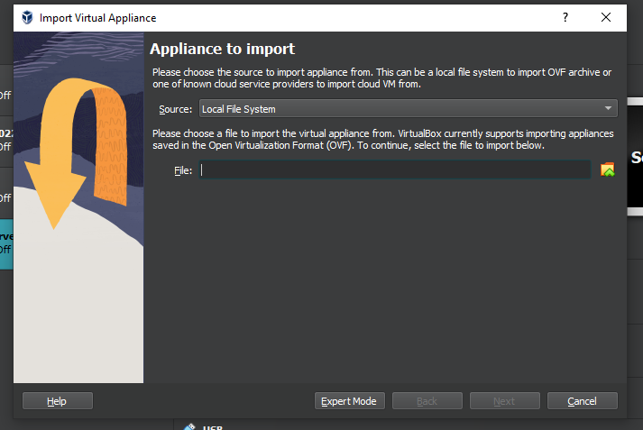

Next locate the Windows Server .ova file, then let it import to VirtualBox.

Now you may run your Virtual Machine. After it has booted up, you will be prompted with a login. Password is “**Pa$$w0rd**”. After that an App called “**Server Manager**” will automatically open up.

**Setting up Active Directory Domain Services in Windows Server**

Step 1: Locate and click on “**Add roles and features**”. 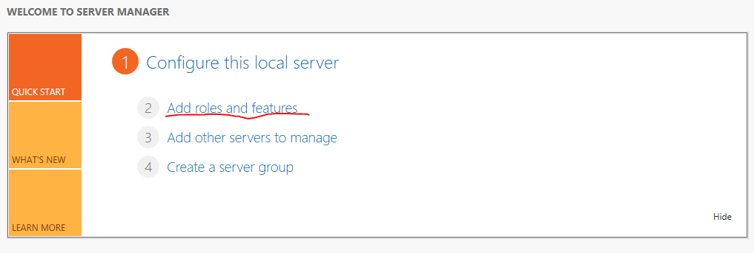

Step 2: Click next, click next again and then one last time.

Step 3: Now locate and click on “**Active Directory Domain Services**”. Then a window will pop up. Click “**Add Features**”. Afterwards click next.

Step 4: Click Next, Click Next again.

Step 5: Click Install and wait.

After “**Active Directory Domain Services**” installed you can close the window. Then afterward you will see a yellow triangle in the top of “**Server Manager**”.



Now click on the yellow triangle and then click on “**Promote this server to a domain controller**”.

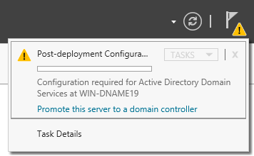

Step 6: A new window will pop up, make sure you click on “**Add a new forest**” then give a **Root Domain Name.** Then click next. 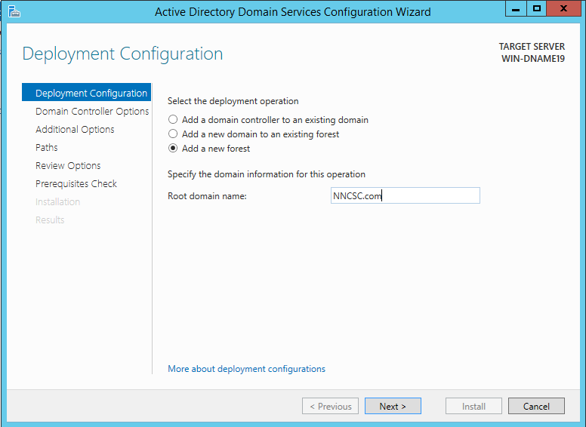

Step 7: Now you will be prompted to give a new password. Use this 🡪 **Pa$$w0rd123**.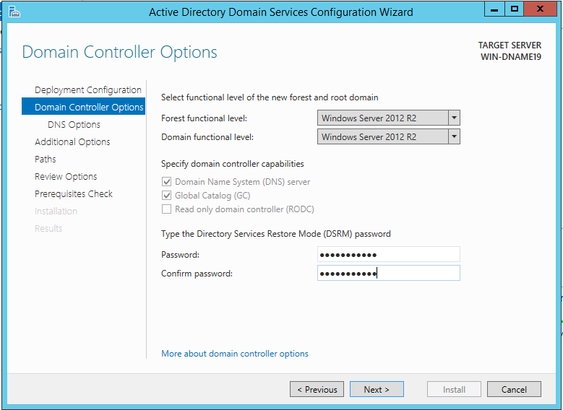

Step 8: Click Next, Click next, Click next, Click next and then click Install.

After installing your Virtual machine will restart. Just wait and enter the password you entered before the restart.

**Setting up DNS in Active Directory**

The same steps that you followed to install “**Active Directory Domain Service**”, is the same to install “**DNS**”.

Step 1: Locate and click on “**Add roles and features**”.

Step 2: Click next, click next, click next.

Step 3: Locate and click on “**DNS Server**”.

Step 4: Click next until you may click Install. Wait for it to complete, once that’s done your “**DNS**” is install.

**Connecting Windows Client to Windows Server**

At this point you should have your windows 10 client imported to VirtualBox. If you don’t not just follow the first steps at the top of the guide.

Step 1: On Windows Server Open your “**Network and Sharing Center**”. You can search that in the search bar. 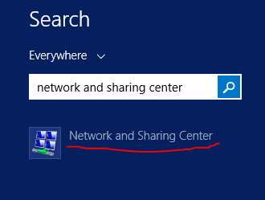

Step 2: After you opened “**Network and Sharing Center**”, click on “**Ethernet**”. 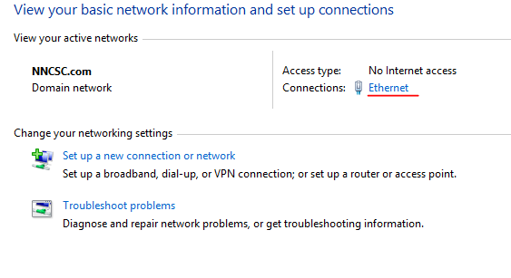

Step 3: Click on “**Properties**” then afterwards disable “**Internet Protocol Version 6**”.

Step 4: Select “**Internet Protocol Version 4**” and then click on “**Properties**”.

Step 5: Enable “**Use the following IP Address**”. And enter a Ip Address, Subnet mask, default gateway and Preferred DNS Server. Then click “**Ok**”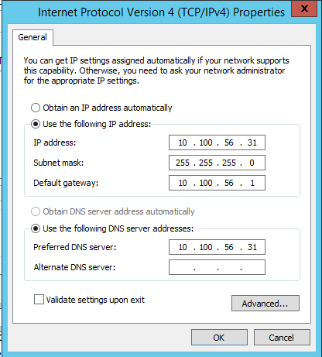

**IMPORTANT 🡪** Make sure that “**Preferred DNS Server**” is the same as you specified Ip address.

Step 6: Now start your Windows 10 Client and locate and open your “Network and Sharing Center”.

Step 7: Now follow the same steps you did in your Windows Server. 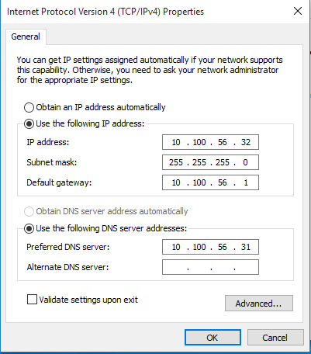

**IMPORTANT 🡪** Change the last Octet of the IP Address of this machine and make sure the “**Preferred DNS Server**” is the same as the Windows Server’s IP Address.

Step 8: Open File Explorer and Right Click on “**This PC**” then click on “**Properties**”.

Step 9: Locate and click on “**Change Settings**”.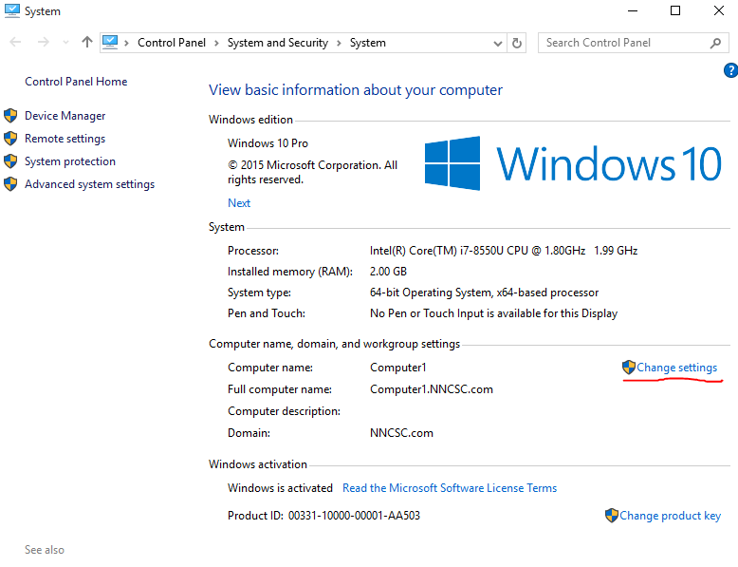

Step 10: Next click on the “**Change**” button. 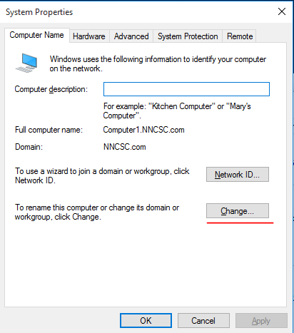

Step 11: Find and enable “**Domain**” and enter your Domain name of your Windows Server.



Step 12: Then enter your admin credentials AKA your Windows Server Username and Password.